
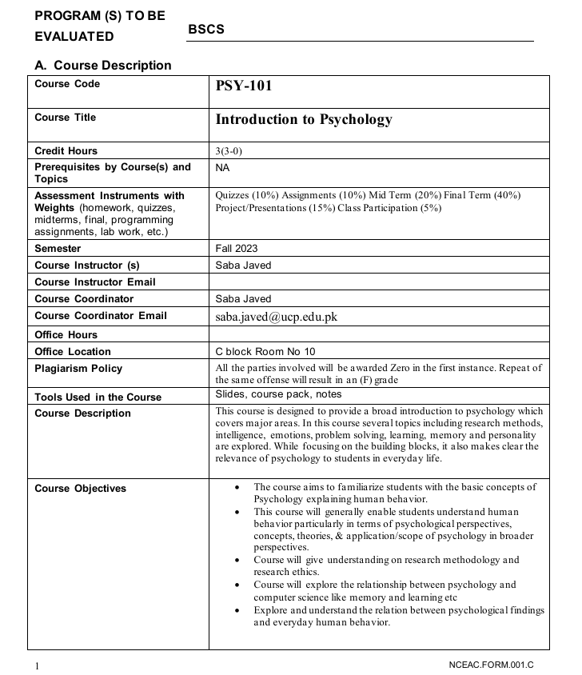

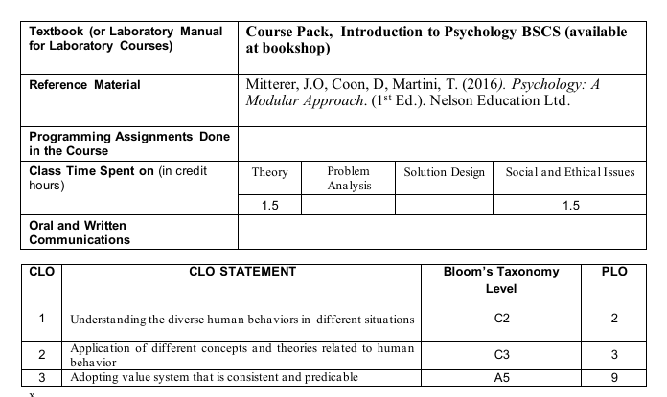

SEMESTER SCHEDULE
Week | Topics | Evaluation Used | Relation to CLO
1st | Introduction to Psychology  - Definition of psychology, overt and covert behavior  - Scope and goals of psychology  - Discuss briefly how psychology connects to computer science, for example, understanding human cognition helps design better user interfaces, chatbots, and intelligent systems. |  | CLO-1
2nd | Historical Perspectives  - Structuralism, functionalism  - Psychology’s current perspectives: behaviorism, psychoanalytic, humanistic, biological, cognitive, sociocultural  - Branches of psychology, clinical, cognitive, educational, environmental, forensic, health, industrial/organizational psychology, consumer psychology  - Short link between cognitive psychology and artificial intelligence, explain how human thought processes, perception, and learning inspire AI models.  Reference: Course pack, Chapter 1 | Assignment 1 | CLO-2
3rd | Research Methods and Ethics  - Experimental and descriptive research: naturalistic  observation, surveys, case studies  - Research ethics  - Highlight ethical parallels in computing –  user data privacy, algorithmic bias, and responsible experimentation in AI and HCI research.  Reference: Course pack, Chapter 2 | Quiz 1 | CLO2
4th | Motivation  - Intrinsic & extrinsic  - Instinct Approaches: Born to Be Motivated  - Drive-Reduction Approaches: Satisfying Our Needs  - Arousal Approaches: Beyond Drive Reduction  - Incentive Approaches: Motivation’s Pull  - Cognitive Approaches: The Thoughts Behind Motivation  - Maslow’s Hierarchy: Ordering Motivational Needs  - Applying the Different Approaches to Motivation  May give as group assignment |  | CLO2, CLO3
5th | Intelligence and its Measurement  - Human intelligence,  - Intellectual Disability, Genetic, cultural, and environmental influences  - Relate to artificial intelligence, compare human intelligence with machine intelligence, discussing data-driven learning versus emotional intelligence.  Reference: Course pack, Chapter 4 | Evaluation: Assignment 2 | CLO2, CLO3
6th | Learning  - Types of learning  - Classical conditioning (spontaneous recovery, generalization, discrimination)  - Learned fears, Systematic desensitization  - Briefly link to reinforcement learning in AI & how principles of conditioning inspired algorithms used to train intelligent systems.  Reference: Course pack, Chapter 5 | Quiz 2 | CLO2, CLO3
7th | Learning  - Operant conditioning,  - Reinforcement & Punishment  - Observational learning and modeling  - Connect to machine learning – relate supervised and unsupervised learning to human observation and reinforcement patterns.  Reference: Course pack, Chapter 5 |  | CLO6
8th | Mid Term |  | CLO2, CLO6
9th | Psychological Disorders  - defining abnormality – 4 Ds |  | CLO2, CLO3
10th | Psychological Disorders (Cont.)  - a brief overview of the spectrum – Depression, anxiety, etc.  Reference: Course pack, Chapter 7 | Assignment 3 | CLO3
11th | Emotional Intelligence  - Understanding emotion, emotional intelligence and emotional regulation  - Discuss relevance of EQ in the software industry, teamwork, leadership, and empathy in design and development processes. | Quiz 3 | CLO3
12th | Personality  - Definition and types of personality, traits  - OCEAN – big 5  - Objective vs. projective personality assessment tools  - Mention personality-based AI models and ethical considerations of behavior prediction and profiling in data analytics.  Reference: Chapter 9 | Quiz 4 (week 14) | CLO2, CLO3,  CLO6
13TH | Stress and Coping  - General Adaptation Syndrome,  - Coping with stress,  - Defense mechanisms  - Learned helplessness  - Discuss digital stress and burnout in computing professions, information overload, and coping strategies for programmers and IT professionals.  Activity: Stress management exercise  Reference: Course pack, Chapter 10 |  | CLO6
14& 15th | Presentation Week (may cover parts of last 2 topics here)

